Practical

Title: Write a program for error detection and correction for 7/8 bits ASCII codes using Hamming codes or CRC.

Part A: Hamming Code (Error Detection and Correction)

Aim:
Write a program to implement Hamming Code for error detection and correction of 7-bit / 8-bit ASCII data.

Theory:
Hamming Code
Hamming Code is an error-detection and error-correction technique developed by R. W. Hamming. It works by adding a number of redundant (parity) bits to the original data bits so that a single-bit error occurring during transmission can not only be detected but also located and corrected at the receiver, without retransmission.
Number of Parity Bits
If the message contains m data bits, the number of parity bits r required must satisfy the relation 2^r ≥ m + r + 1. For a 7-bit ASCII character, 4 parity bits are required (r = 4, total code length = 11). For an 8-bit ASCII character, 4 parity bits are also required (r = 4, total code length = 12).
Placement of Bits
In the encoded codeword, bit positions that are powers of two (1, 2, 4, 8, …) are reserved for parity bits (P1, P2, P4, P8, …), and all remaining positions hold the data bits, in order.
Calculating Parity Bits
Each parity bit Pi (placed at position 2^i) checks all bit positions whose binary representation has the i-th bit set. Pi is set so that the total number of 1s among the positions it checks (including Pi itself) is even (even parity).
Error Detection and Correction
At the receiver, the same parity checks are recomputed on the received codeword. If a bit has been flipped during transmission, the checks that include that bit will fail. The sum of the positions of the failing parity checks gives the decimal position of the erroneous bit (the syndrome). That bit is then complemented to correct the error, and the original data bits are extracted from the non-parity positions.

Algorithm:
Step 1: Read m, the number of data bits (7 or 8), and the m data bits.
Step 2: Compute the number of parity bits r such that 2^r ≥ m + r + 1, and the total codeword length n = m + r.
Step 3: Place the data bits into the non-power-of-2 positions of the codeword; initialize parity positions (powers of 2) to 0.
Step 4: For each parity position 2^i, XOR all bits whose position has that bit set, and store the result as the parity bit.
Step 5: Display the encoded Hamming codeword.
Step 6: Simulate transmission by flipping one bit of the codeword at a user-given position.
Step 7: At the receiver, recompute each parity check on the received codeword; add up the positions of the checks that fail to obtain the syndrome.
Step 8: If the syndrome is 0, report no error; otherwise, complement the bit at the syndrome position to correct it.
Step 9: Extract and display the corrected data bits from the non-parity positions. Stop.

Code:
#include <stdio.h>

int main() {
int n;
printf("Enter number of data bits: ");
scanf("%d", &n);

int data[100];
printf("Enter the data bits (0 or 1): ");
for (int i = 0; i < n; i++) {
if(n > 100) {
printf("Number of data bits should not exceed 100.\n");
return 0;
}
scanf("%d", &data[i]);
}

int r = 0, p = 1;
while (p < n + r + 1) { r++; p = p * 2; }

int total_len = n + r;
int codeword[100];
int data_idx = 0;

for (int i = 1; i <= total_len; i++) {
int temp = i;
while (temp > 1 && temp % 2 == 0) temp = temp / 2;
if (temp == 1) codeword[i] = 0;
else { codeword[i] = data[data_idx]; data_idx++; }
}

for (int i = 0; i < r; i++) {
int parity_pos = 1;
for (int k = 0; k < i; k++) parity_pos = parity_pos * 2;
int sum = 0;
for (int j = 1; j <= total_len; j++)
if ((j / parity_pos) % 2 == 1) sum = sum + codeword[j];
codeword[parity_pos] = sum % 2;
}

printf("Hamming Codeword: ");
for (int i = 1; i <= total_len; i++) printf("%d ", codeword[i]);
printf("\n");
return 0;
}

Output:
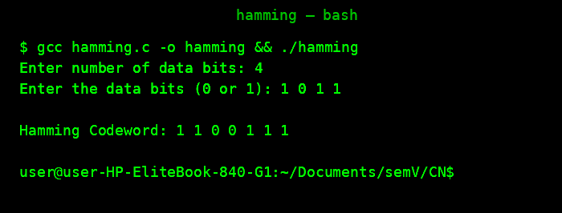

Part B: Cyclic Redundancy Check (CRC)

Aim:
Write a program to implement the Cyclic Redundancy Check (CRC) technique for error detection of 7-bit / 8-bit ASCII data.

Theory:
CRC (Cyclic Redundancy Check)
CRC is an error-detection technique used in digital networks and storage devices to detect accidental changes to raw data. The sender and receiver agree in advance on a generator polynomial (a fixed binary bit pattern). The sender appends a checksum, computed from the data and the generator, to the data before transmission; the receiver uses the same generator to verify that the received data is unaltered.
Generating the CRC (Sender Side)
Let the data be of length k bits and the generator polynomial be of length g bits. The sender appends (g − 1) zero bits to the end of the data to form an augmented message, and performs binary (modulo-2, XOR-based) division of this augmented message by the generator polynomial. The (g − 1)-bit remainder obtained is the CRC checksum, which replaces the appended zeros to form the final codeword that is transmitted.
Checking the CRC (Receiver Side)
The receiver divides the received codeword (data + CRC) by the same generator polynomial using modulo-2 division. If the remainder is all zeros, the data is assumed to be error-free; if the remainder is non-zero, an error occurred during transmission.
Modulo-2 (XOR) Division
Unlike ordinary binary division, modulo-2 division performs subtraction using the XOR operation and does not involve any borrow or carry, which makes it simple to implement in hardware and software.

Algorithm:
Step 1: Read the data bits and the generator polynomial bits.
Step 2: Append (g − 1) zero bits to the data, where g is the length of the generator.
Step 3: Perform modulo-2 (XOR) division of the augmented data by the generator polynomial.
Step 4: Replace the appended zeros with the remainder obtained; this forms the transmitted codeword (data + CRC).
Step 5: Display the transmitted codeword.
Step 6: Simulate transmission by optionally flipping one bit of the codeword at a user-given position.
Step 7: At the receiver, divide the received codeword by the same generator polynomial using modulo-2 division.
Step 8: If the remainder is all zeros, report that no error was detected; otherwise, report that an error was detected. Stop.

Code:
#include <iostream>
#include <vector>
using namespace std;

vector<int> crc(vector<int> data, const vector<int>& generator) {
int n = data.size();
int k = generator.size();
for (int i = 0; i <= n - k; i++) {
if (data[i] == 1) {
for (int j = 0; j < k; j++) {
data[i + j] = data[i + j] ^ generator[j];
}
}
}
vector<int> remainder;
for (int i = n - (k - 1); i < n; i++) {
remainder.push_back(data[i]);
}
return remainder;
}

void printBits(const vector<int>& bits) {
for (int bit : bits) { cout << bit; }
cout << endl;
}

bool isZero(const vector<int>& remainder) {
for (int bit : remainder) {
if (bit != 0) return false;
}
return true;
}

int main() {
int dataSize;
cout << "Enter number of data bits: ";
cin >> dataSize;
vector<int> data(dataSize);
cout << "Enter data bits: ";
for (int i = 0; i < dataSize; i++) cin >> data[i];

int generatorSize;
cout << "Enter number of generator bits: ";
cin >> generatorSize;
vector<int> generator(generatorSize);
cout << "Enter generator bits: ";
for (int i = 0; i < generatorSize; i++) cin >> generator[i];

cout << "\n========== SENDER SIDE ==========\n";
cout << "Original Data: "; printBits(data);
cout << "Generator: "; printBits(generator);

vector<int> transmittedData = data;
for (int i = 0; i < generatorSize - 1; i++)
transmittedData.push_back(0);
cout << "Data after appending zeros: ";
printBits(transmittedData);

vector<int> remainder = crc(transmittedData, generator);
cout << "CRC Remainder: "; printBits(remainder);

vector<int> codeword = data;
for (int bit : remainder) codeword.push_back(bit);
cout << "Final Transmitted Codeword: ";
printBits(codeword);

cout << "\n========== RECEIVER SIDE ==========\n";
int receivedSize;
cout << "Enter number of received bits: ";
cin >> receivedSize;
vector<int> receivedData(receivedSize);
cout << "Enter received data bits: ";
for (int i = 0; i < receivedSize; i++) cin >> receivedData[i];

cout << "Received Codeword: "; printBits(receivedData);
vector<int> receiverRemainder = crc(receivedData, generator);
cout << "Receiver Remainder: "; printBits(receiverRemainder);

if (isZero(receiverRemainder)) {
cout << "\nNo error detected.\n";
cout << "Data ACCEPTED.\n";
} else {
cout << "\nError detected!\n";
cout << "Data REJECTED.\n";
}
return 0;
}

Output:
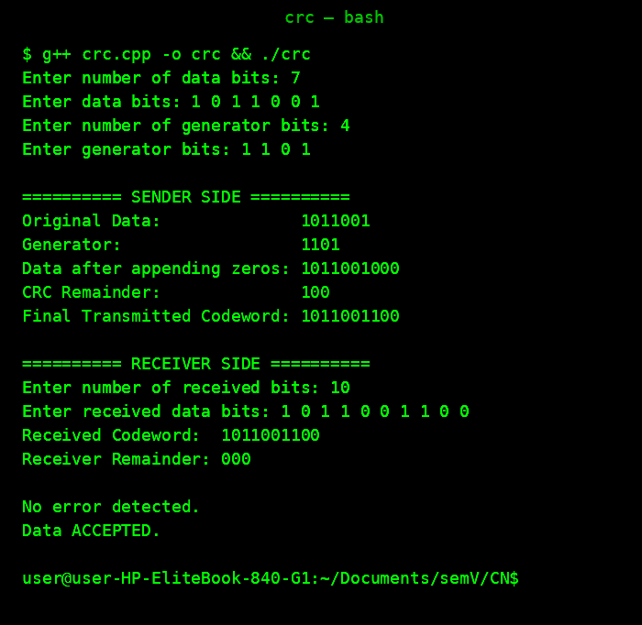

Conclusion:
The program successfully implements the Cyclic Redundancy Check technique for 7/8-bit ASCII data. It generates the CRC checksum at the sender by performing modulo-2 division of the data by the chosen generator polynomial and appends it to form the transmitted codeword. At the receiver, dividing the received codeword by the same generator correctly identifies whether the data was received without error (zero remainder) or was corrupted during transmission (non-zero remainder). This confirms that CRC is an effective and simple method for detecting transmission errors.

